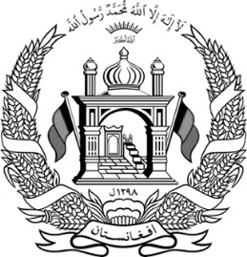

**Islamic Republic of Afghanistan**

**Ministry of Interior Affairs**

**Department of Population Statistics**

**Population Statistics Office**

**Province: XXXXXX**

**District: XXXXXX**

**No: XXXXXX Village: XXXXXX**

**Price: 10 AFN Home No:**

|  |  |  |  |  |  |  |  |  |  |  |
| --- | --- | --- | --- | --- | --- | --- | --- | --- | --- | --- |
| **Identification** | | | | **Physical Characteristics** | | | | |  | |
| Name | | **XXXXXX** | | Height | | | **Medium** | |
| Color of eye | | | **Hazel** | |
| Father’s Name | | **XXXXXX** | | Eyebrow | | | **Separated** | |
| Color of skin | | | **Wheaten** | |
| Grand Father’s Name | | **XXXXXX** | | Color of hair | | | **Black** | |
| Other sings | | |  | |
| Place of Birth | | **Mentioned Village** | | Disability | | |  | |
| Date of Birth | |  | | | | | | | | |
| Religion | | **Islam** | | **Military Service** | | | | | **Nomad/ Seasonal Residence** | |
| Ethnicity | | **Afghan** | | Entry date | |  | | | Summer |  |
| Occupation | | **XXXXXX** | | Releasing Date | |  | | | Winter |  |
| Gender | | **XXXXXX** | | Division | |  | | | Tribe |  |
| Marital Status | | **Single** | | Other | |  | | | Head of Tribe |  |
| Family No. | |  | |  | | Volume No.**XX**, Page No. **XX**, Registry No. **XX** | | | | |
| Languages | | Mother Tongue | | **XXXXXX** | |
| Sukok No. , Date: **(XXXXXX)**  **(XXXXXX)** | | | | |
| Foreign | |  | |
| **Signature of Authorized Officer** | | | | **Signature of Chief Officer** | | | | | **Signature of ID Holder** | |
| Name | Grade | |  | Name | Grade | | |  | Father’s ID: Volume No. **XX**, Page No. **XX**, Registry No. **XX** | |
|  |  | |  |  |  | | |  |

Certified true translation.